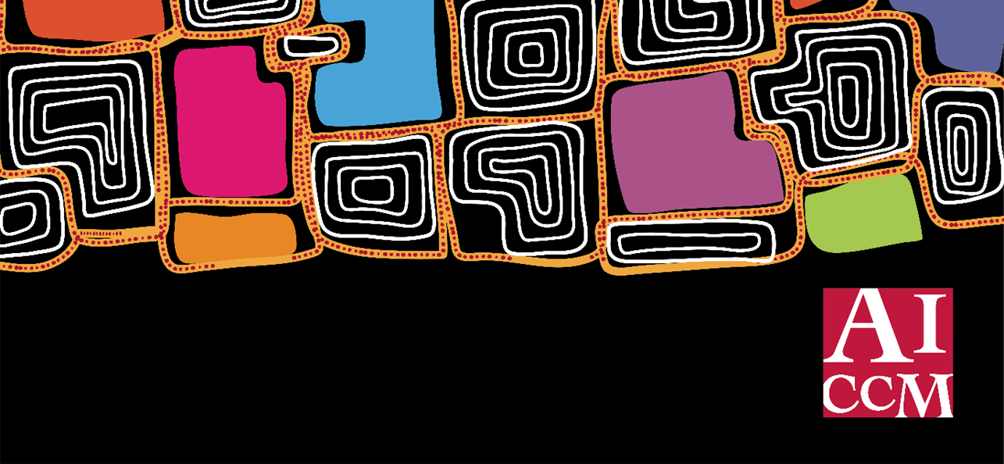

**AICCM CONFERENCE SUBMISSION TEMPLATE**

**More than Materials: Collaborative Approaches in Cultural Heritage Conservation**

**National Conference, Kurilpa | South Brisbane, 12-14 November 2025**

**Please provide the following information in your submission:**

1. Type of Presentation and length:

*Is this a Spoken Paper, PowerPoint Poster, or an idea for another type of presentation such as a panel discussion, performance, virtual presentation or audio-visual/film.*

2. Title of Presentation or Poster:

3. Author/s:

4. Main author/speaker: *(for correspondence)*

* A brief biography/introduction to who you are:
* Where you work/affiliations:
* AICCM membership status:

5. Contact email address:

6.Abstract (250 words):

*Describe your topic, your principal findings and achievements, and summarise your points of discussion. Note that all presentations must respect Indigenous Cultural and Intellectual Property (ICIP) rights. Resources and guidelines can be provided through AICCM to support this.*

7. Email submission to: [secretariat@aiccm.org.au](mailto:secretariat@aiccm.org.au) by **16 May 2025**