Student Bursary Application Form |  |  | 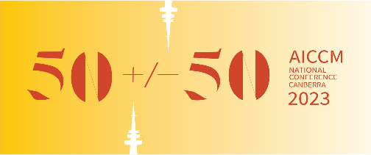
First name/s
Last name/s
Email
Phone
AICCM membership status
□ Not a member  □ membership pending | □ Current Student member  □ Current Full member
Tertiary institution / University
Course of study
□ Postgraduate  □ Undergraduate | □ By coursework  □ By research
Current enrolment status
□ Part time  □ Full time | □ Deferred  □ suspended
Details of academic reference in the letter of recommendation provided
Name
Contact email or phone
A bit about you
(Please answer the following in no more than 250 words. Dot points are acceptable.)
What achievement are you most proud of since you started studying?
What personal or academic strengths will you bring to the field of materials conservation?
What are your goals in the field of heritage materials conservation?
In what area of your academic progress do you feel you need to direct your efforts to achieve your goals?
What do you hope to gain from attending the AICCM National Conference 2023?

