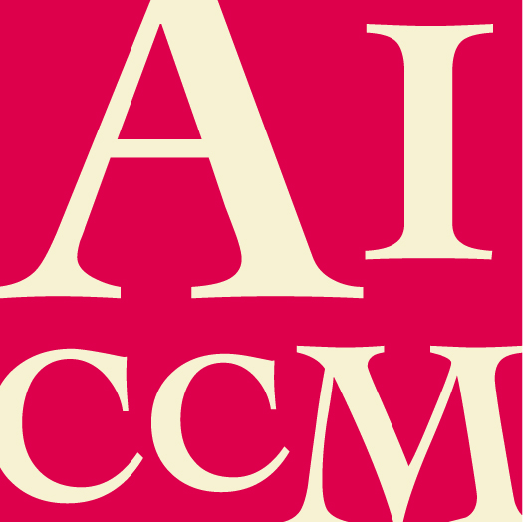 | Outstanding Research in the Field of  Material Conservation Award  NOMINATION FORM

This award is to acknowledge an AICCM member or research team who has undertaken substantial research in the field of material conservation, and who has shared this information within the national and/or international material conservation profession via the AICCM Bulletin.

All sections of this form must be completed for this nomination to be valid.
At least one member of the research team is an AICCM member.

Nominee details

Name of nominee

Name of employer / organisation

Position / Title

Contact phone number

Contact email address

I consent to the nominee receiving a copy of this nomination.

Summary of why nominee should receive award (100 word limit)

Response to Selection Criteria (attached at the end of this form)

- Please describe how the nominee has undertaken substantial research in the field of material conservation, and importantly, site the Bulletin issue where the research has been made available to the conservation profession.

Additional Comments

- Please make any additional comments in support of this nomination. The nominator is encouraged to include any relevant support material eg media coverage, letters of support etc.

Nominator and Seconder Details

Please supply your and the seconder’s details, in the event that the Selection Panel need to confirm nomination information.

 | Nominator | Seconder
Name
Organisation
Position/Title
Address
Phone no.
Fax no.
Email
Signature
Date

Submission details

Please return this completed form and any support material to AICCM Secretariat
secretariat@aiccm.org.au by the due date.

Selection Criteria

- At least one member of the research team is an AICCM member.
- Open to any person/s (including conservators, non-conservators, undergraduate and post-graduate students) who carry out original research into the conservation of cultural material that involves the use of new processes and/or analytical techniques. Processes can be technical, methodological and conceptual in nature.
- Research must be published in the AICCM peer-reviewed journal, The Bulletin.
- The topic of research must have relevance for (either incorporating or can be applied to) the Australian context.
- Research can cover topic including but not reserved to, materials and techniques of artists/crafts persons, deterioration of collections, conservation and restoration treatments, all aspects of preventive conservation, storage/display and transport of collections, authenticity of works of art and artifacts etc.
- Involvement of the research industry (e.g. CSIRO, ARC etc.), cross-institutional and cross discipline collaboration is preferred.
- If more than one author of the research paper the award to go to the primary author.
- A nominee is ineligible to receive the award if they have been awarded “Outstanding Research in the Field of Materials Conservation” within the last 5 years.
- Where the recipient is unable to accept the award as a financial reimbursement, the award may be used towards payment of AICCM membership, publications or event registration.
- The Selection Committee may choose to defer making an award if it considers that candidates have not met the criteria.

Evaluation Rubric

Category | Exceeds award requirements | Meets award requirements | Does not meet award requirements
Publication | - Publication in The Bulletin  - Promotion through other publication and symposia | - Publication in The Bulletin | - Published but not in The Bulletin
Originality and quality | - Written in an interesting style and voice  - Very informative and deeply reflective  - Well organised | - Written in a somewhat interesting style and voice  - Some new information on the topic  - Well organised | - No style or clear voice  - No new information on the topic  - Poorly organised
Relevance | - Highly topical with immediate applicability or dealing with an area of key need  - Extremely relevant to the Australian context | - Topical research with broad interest to industry or applicable research into specialty area  - Topic transferable to the Australian context | - Too broadly generic or too specialised as to make it useful for application  - Topic not applicable to Australian context
Multi-disciplinary | - Involves multiple research partners from academia, government and/or industry  - Extends beyond conservation research drawing upon multiple disciplines | - Single researcher  - Research is focused solely on conservation outcomes | - Research does not focus on conservation outcomes

