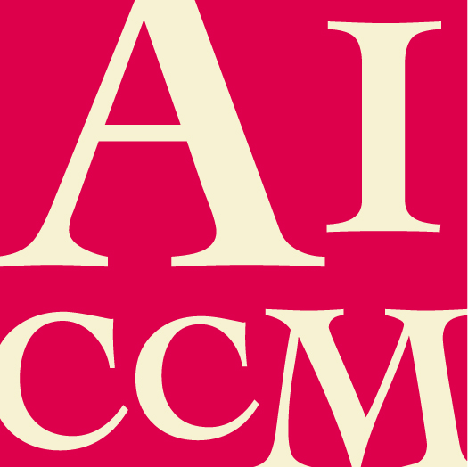 | AICCM Medal  NOMINATION FORM

This award recognises career long contributors to Conservation and acknowledges skills sharing across levels of seniority ensuring that skills are not lost from the profession.
The nominee must be a current financial member of AICCM.

All sections of this form must be completed for this nomination to be valid.

If information in this nomination is more relevant to a different AICCM Award category, this nomination can be considered in that category instead. Please state any category you DO NOT wish this application to be considered for.

Nominee details

Name of nominee

Name of employer / organisation

Position / Title

Contact phone number

Contact email address

I consent to the nominee receiving a copy of this nomination.

Summary of why nominee should receive award (100 word limit)

Response to Selection Criteria (attached at the end of this form)

- Please describe how the nominee has met the selection criteria.

Additional comments

- Please make any additional comments in support of this nomination. The nominator is encouraged to include any relevant support material (for example media coverage, letters of support etc.). You can include information and excerpts from the support material in your response to selection criteria above as this support material should not be used as your response to selection criteria, rather as evidence of it.

Nominator and Seconder details

Please supply your and the seconder’s details, in the event that the Selection Panel need to confirm nomination information.

 | Nominator | Seconder
Name
Organisation
Position/Title
Address
Phone no.
Email
Signature
Date

Submission details

Please return this completed form and any support material to AICCM Secretariat
secretariat@aiccm.org.au by the due date.

Selection Criteria

- The nominee must be a current member of AICCM.
- evidence of length and complexity of their contribution to and promotion of the profession.
- involvement, either past or present, in AICCM divisional or national activities. Details of this involvement may also include a list of published materials.
- Demonstrable long term benefits of their contribution to the profession nationally or internationally.
- Evidence of mentoring within the profession and participation in formal and informal networking activities to the benefit of conservation
- Evidence of contribution via working with allied professions and the public.
- Cannot have received the award before.
- The Selection Committee may choose to defer making an award if it considers that candidates have not met the criteria.

