THE AICCM INSTRUCTIONS FOR AUTHORS
About this journal
The AICCM Bulletin encourages the submission of original and quality papers, including research reports, discussion papers, literature surveys, thematic bibliographies, summaries of research papers and dissertations. The AICCM Bulletin is a hard copy and online peer reviewed journal produced by the Australian Institute for the Conservation of Cultural Materials (AICCM) since 1975 and is now published by Taylors & Francis Publishing. The journal has an interdisciplinary focus and:
- Disseminates new information gathered about the materiality, nature, condition, deterioration and treatment of cultural collections within Australia and the Asia-Pacific region
- Promotes interdisciplinary research activity in cultural materials conservation
- Presents a forum for new ideas and thinking with regards to conservation management, conservation ethics, cultural engagement, sustainability and wider professional concerns in the region
- Disseminates new information and novel methods useful to the conservation profession world-wide.

Two volumes will be published by Taylors & Francis Publishing each year.

The Bulletin does not accept papers that have been published elsewhere, with the following exception: papers that have been presented at AICCM SIG meetings, conferences or workshops in the form of Pre-prints, Post-prints, articles or presentations that have not previously been peer reviewed. Acceptance of such submissions is based on the importance of the research to the conservation profession, the benefits of it being published in a peer reviewed journal and clear reference to its earlier beginnings. Such submissions will be considered at the discretion of the Editor.

It is a condition of the AICCM Bulletin that, on acceptance of the article by the journal editor, copyright must be assigned to the publisher.

Further instructions for authors and the submission procedure, please refer to the Taylors & Francis Publishing instruction for authors.

The AICCM Instruction for Authors are also relevant to the AICCM Newsletter.

Papers must be submitted in English. If the author is not fluent in English, a professional translator should be employed to translate the paper prior to submission.

Peer review
Taylor & Francis is committed to peer-review integrity and upholding the highest standards of review. Once your paper has been assessed for suitability by the editor, it will then be double blind peer-reviewed by independent, anonymous expert referees. Find out more about what to expect during peer review and read our guidance on publishing ethics.

Preparing your article
Your paper should be compiled in the following order: title page; abstract; keywords; main text introduction, materials and methods, results, discussion; acknowledgments; project details including funding, partner agreements and ethics approval details; disclosure statement; data availability statement; references; appendices (as appropriate); table(s) with caption(s) (on individual pages); figures; figure captions (as a list).

Manuscript components
Articles may include the following components, in this order:
- The title
- Abstract (100–200 words)
- Keywords (4–8, lowercase)
- The main body of the paper, which may include sub-headings (e.g Project method, Results, Discussion etc.)
- Up to 6 illustrations, including photographs, line drawings and tables, plus a list of captions for figures and tables
- A conclusion
- List of references
- A materials list, if applicable, including manufacturer(s)/supplier(s) details
- Acknowledgements: if applicable. Please ensure that those included agree to their name being acknowledged
- Supplementary material

Please note: Two versions of your paper will be requested at the time of submission:
- One with author details at the beginning of the paper, author affiliations and author biographies.
- One with no author details. All of the sections above should be removed upon submission.

Word count
Please include a word count for your paper. A typical paper for this journal should not exceed 8000 words, inclusive of endnotes, footnotes, figure captions, references, and tables.

Style guidelines
Please refer to these quick style guidelines when preparing your paper, rather than any published articles or a sample copy.

Please Australian spelling consistently throughout your manuscript. For spelling guidelines, use The Australian Oxford dictionary or The Macquarie dictionary.

Please use single quotation marks, except where ‘a quotation is “within” a quotation’. Please note that long quotations should be indented without quotation marks.

Third person is preferable for AICCM Bulletin papers. Articles originally written for oral presentation should be submitted in a style suitable for written communication.

Formatting and templates
Papers may be submitted in Word or LaTeX formats. Figures should be saved separately from the text. To assist you in preparing your paper, we provide formatting template(s).

Word templates are available for this journal. Please save the template to your hard drive, ready for use.

If you are not able to use the templates via these links (or if you have any other template queries) please contact Taylor and Frances at http://authorservices.taylorandfrancis.com/contact/

Guidelines for Ethical Research in Australian Indigenous Studies
The Guidelines for Ethical Research in Australian Indigenous Studies (2020) includes 14 principles for ethical research. Researchers and authors should be aware of all principles, for example:
Principle 1: Recognition of the diversity and uniqueness of peoples, as well as of individuals, is essential. Research in Indigenous studies must recognise the diversity of Indigenous peoples, including their different languages, cultures, histories and perspectives. It is also important to recognise the diversity of individuals and groups within communities.

For further information see:
Australian Institute of Aboriginal and Torres Strait Islander Studies 2020, A Guide to Applying the AIATSIS Code of Ethics for Aboriginal and Torres Strait Islander Research, Canberra, viewed 10 June 2020,
< https://aiatsis.gov.au/sites/default/files/2020-10/aiatsis-guide-applying-code-ethics_0.pdf>.

References and in text citations
Please use the AICCM reference manual when preparing your paper (download from the AICCM or the Taylor & Francis site. All in text citations should appear in the reference list at the end of the paper in alphabetical order. The AICCM reference manual is based on the author-date (Harvard) citation style as detailed in:
Snooks & Co 2002, Style Manual for authors, editors and printers, 6th edn, John Wiley & Sons, Milton.

Checklist: what to include
- Title: The paper title should be concise, accurate, and informative. Titles are often used by search engines and other information retrieval systems. The title should be specific and it should contain words that readers might be searching for.
- Author details. Please ensure all listed authors meet the Taylor & Francis authorship criteria and you have consulted with item 3.1 in the Australian Institute of Aboriginal and Torres Strait Islander Studies 2020, A Guide to Applying the AIATSIS Code of Ethics for Aboriginal and Torres Strait Islander Research. Please include all authors’ full names, affiliations, postal addresses, telephone numbers and email addresses on one version with author details and remove author details on the version without author details. Where available, please also include ORCiDs and social media handles (Facebook, Twitter or LinkedIn). One author will need to be identified as the corresponding author, with their email address normally displayed in the article PDF (depending on the journal) and the online article. Authors’ affiliations are the affiliations where the research was conducted. If any of the named co-authors moves affiliation during the peer-review process, the new affiliation can be given as a footnote. Please note that no changes to affiliation can be made after your paper is accepted. Read more on authorship.
- Authorship: To your knowledge, are authors and contributors rightfully assigned? Knowledge and inclusion: To your knowledge and as it appears in the paper, were the intellectual property rights holders consulted and suitably attributed? Please refer to the above A Guide to Applying the AIATSIS Code of Ethics for Aboriginal and Torres Strait Islander Research.
- A non-structured abstract of 100-200 words. Indicate the abstract paragraph with a heading or by reducing the font size. Advice on writing abstracts is available here. The abstract is an important part of the article and will be used in Abstracting and Indexing services where the journal is listed, searched by Google and other search engines, and freely available online. Abstracts should be succinct but sufficiently comprehensive to provide a comprehensible summary of the article.
- Graphical abstract. This is an image to give readers a clear idea of the content of your article. It should be a maximum width of 525 pixels. If your image is narrower than 525 pixels, please place it on a white background 525 pixels wide to ensure the dimensions are maintained. Save the graphical abstract as a .jpg, .png, or .gif. Please do not embed it in the manuscript file but save it as a separate file, labelled GraphicalAbstract1.
- You can opt to include a video abstract with your article. Find out how these can help your work reach a wider audience, and what to think about when filming.
- 4-8 keywords. Read making your article more discoverable, including information on choosing a title and search engine optimization.
- Acknowledgements. for those that have contributed to the research.
- Project details. Please supply all details required by your funding and grant-awarding bodies, project agreements and ethics applications as follows:
For single agency grants
This work was supported by the <Funding Agency> under Grant <number xxxx>.
For multiple agency grants
This work was supported by the <Funding Agency 1> under Grant <number xxxx>; <Funding Agency 2> under Grant <number xxxx>; and <Funding Agency 3> under Grant <number xxxx>.
- Disclosure statement. This is to acknowledge any financial interest or benefit that has arisen from the direct applications of your research. Further guidance on what is a conflict of interest and how to disclose it.
- Biographical note. Please supply a short biographical note for each author. This could be adapted from your departmental website or academic networking profile and should be relatively brief (e.g. no more than 100 words).
- Data Availability Statement. If there is a data set associated with the paper, please provide information about where the data supporting the results or analyses presente­d in the paper can be found. Where applicable, this should include the hyperlink, DOI or other persistent identifier associated with the data set(s). Templates are also available to support authors.
- Data deposition. If you choose to share or make the data underlying the study open, please deposit your data in a recognised data repository prior to or at the time of submission. You will be asked to provide the DOI, pre-reserved DOI, or other persistent identifier for the data set.
- Geolocation information. Submitting a geolocation information section, as a separate paragraph before your acknowledgements, means we can index your paper’s study area accurately in JournalMap’s geographic literature database and make your article more discoverable to others. More information.
- Supplemental online material. Supplemental material can be a video, dataset, fileset, sound file or anything which supports (and is pertinent to) your paper. We publish supplemental material online via Figshare. Find out more about supplemental material and how to submit it with your article. See Appendix 1 for further information.
- Figures. Figures should be high quality (1200 dpi for line art, 600 dpi for grayscale and 300 dpi for colour). Figures should be supplied in one of our preferred file formats: EPS, PS, JPEG, GIF, or Microsoft Word (DOC or DOCX). For information relating to other file types, please consult our Submission of electronic artwork document. Within the text, figures and tables should be referred to by number (Figure 1; Table 1), and preferred position, sizing, and groupings in the text should be clearly indicated. The acceptable total is six, and charges apply to the printing of figures in colour but not the electronic version (see below for details). For captions use the following conventions:
- Figure 1. Arthur Boyd, Butterfly Man, 1943, oil on muslin on cardboard, 555 x 755 mm, Heide Museum of Modern Art, Bullen, Bequest of John and Sunday Reed 1982. Arthur Boyd’s work reproduced with the permission of Bundanon Trust.
- For composite images, label each sub image with a lower case letter, for example:
Figure 8 Cross section details from Staring out game, a. BSE and corresponding b. visible and c. UVF images
Indicate locations on the figure with lower case letters, for example a.
- Tables. Tables should present new information rather than duplicating what is in the text. Readers should be able to interpret the table without reference to the text. Please supply editable files.
- Equations. If you are submitting your manuscript as a Word document, please ensure that equations are editable. More information about mathematical symbols and equations.
- Units. Please use SI units (non-italicised).
- Quotations: Please use single quotation marks, except where ‘a quotation is “within” a quotation’. Please note that long quotations greater than 30 words should be indented without quotation marks. An in text citation should appear at the end of each quotation.
- Capitalisation: should be kept to a minimum. Do not use capitals for words like ‘conservator’. Use lower case for generic references (‘Australian galleries’); capitals for specifics (‘the National Gallery of Victoria’ or ‘the University of Melbourne’). Include the location when referring to institutional names, for example Heide Museum of Art, Bulleen.
- Italicisation: As a general rule, foreign words and phrases should be used only if there is no precise English equivalent. Latin words and legislation should be italicised, for example Xanthorrhoea, P. aeruginosa, and Victorian Heritage Act 1995.
- Acronyms and abbreviations: should be spelled out in the first instance that they are used, e.g ‘The Australian Institute for the Conservation of Cultural Materials (AICCM)’. Thereafter, the acronym can be given.
- Expressions of time or events: Either the ‘20th century’ or ‘Twentieth Century’ can be used, however it must be consistent in the paper submitted. Use the ‘Second World War’ and not ‘World War 2’.
- Possessives: For names ending in s use Thomas’s, Harris’s.
- Materials: For products, generic or chemical names should be used as well as trade names, wherever possible. Example: Orvus WA Paste (sodium lauryl sulfate). If a trade name is very well known, it is not necessary to give the generic or chemical name. Example: Paraloid B-72. When trade names must be used, and when the name is a registered trademark, the trade name should be capitalised. Commercial products referred to in the paper should be listed by trade name, composition (if known) and the supplier’s or manufacturer’s postal address, telephone and fax numbers, and email address, if applicable, under the heading ‘Materials’ at the end of the paper.

Using third-party material in your paper
You must obtain the necessary permission to reuse third-party material in your article. The use of short extracts of text and some other types of material is usually permitted, on a limited basis, for the purposes of criticism and review without securing formal permission. If you wish to include any material in your paper for which you do not hold copyright, and which is not covered by this informal agreement, you will need to obtain written permission from the copyright owner prior to submission. More information on requesting permission to reproduce work(s) under copyright. More information on consent from image subjects.

Conditions of Submission
By submitting to this journal, authors acknowledge and accept that articles are considered for publication on the basis that:
- The article presents original work that is not being considered or reviewed by any other publication, and has not been published elsewhere in the same or a similar form;
- All authors are aware of, and have consented to, the submission to the journal;
- Due regard has been paid to ethical considerations relating to the work reported;
- The article contains, to the best of the authors' knowledge, no libellous or unlawful statements.

Submitting your paper
Please submit your paper via the Taylors & Francis submission portal. If this is the first time, you may need to create an account and it is also worth obtaining an ORCID number which tracks your research.
<https://RP.tandfonline.com/submission/create?journalCode=YBAC>

The submitting author will need the author and co-author details, paper in two versions with author details and without author details, and figure and tables as separate files. Please title your files as ‘Figure 3_Paper title (abbreviated version)’ and do not use the author names for purposes of anonymity.

If you are submitting in LaTeX, please convert the files to PDF beforehand (you will also need to upload your LaTeX source files with the PDF.

On acceptance, we recommend that you keep a copy of your Accepted Manuscript. Find out more about sharing your work. Also see below for open access and sharing your work.

Publication charges
There are no submission fees, publication fees, or page charges for this journal. A fee is charged for the reproduction of colour figures, images, or diagrams. No fee is charged for figures printed in black and white.

Charges for colour figures in print are £300 per figure ($400 US Dollars; $500 Australian Dollars; €350). For more than 4 colour figures, figures 5 and above will be charged at £50 per figure ($75 US Dollars; $100 Australian Dollars; €65 Euros). Depending on your location, these charges may be subject to local taxes.

Charges for the reproduction of colour figures in the AICCM Bulletin are set by Taylor & Francis. The AICCM Bulletin is funded by AICCM membership fees and these charges are unable to be absorbed. Authors wishing to reproduce colour figures in their publications will be required to pay this fee.

Copyright options
Copyright allows you to protect your original material, and stop others from using your work without your permission. Taylor & Francis offers a number of different license and reuse options, including Creative Commons licenses when publishing open access. Read more on publishing agreements.

Open access

This journal gives authors the option to publish open access via our Open Select publishing program, making it free to access online immediately on publication. Many funders mandate publishing your research open access; you can check open access funder policies and mandates here.
Taylor & Francis Open Select gives you, your institution or funder the option of paying an article publishing charge (APC) to make an article open access. Please contact openaccess@tandf.co.uk if you would like to find out more, or go to our Author Services website.
For more information on license options, embargo periods and APCs for this journal please go here.
On publication, you will be able to view, download and check your article’s metrics (downloads, citations and Altmetric data) via My Authored Works on Taylor & Francis Online. This is where you can access every article you have published with us, as well as your free eprints link, so you can quickly and easily share your work with friends and colleagues.

Green Open Access (OA)

Using your eprints
We want you to share your article, be able to highlight the importance of your research, and ensure it has impact. Every Taylor & Francis author who publishes in a subscription journal gets 50 free eprints to share with colleagues as soon as their article is published on Taylor & Francis Online.

Author’s Original Manuscript (AOM)
This is your original manuscript (often called a “preprint”), and you can share this as much as you like. If you do decide to post it anywhere, including on a scholarly collaboration network, we would recommend you use an amended version of the wording below to encourage usage and citation of your final, published article (the Version of Record).

Accepted Manuscript (AM)
As a Taylor & Francis author, you can post your Accepted Manuscript (AM) on your personal website at any point after publication of your article (this includes posting to Facebook, Google groups, and LinkedIn plus linking from Twitter). To encourage citation of your work (and be able to monitor and understand who is reading it using article metrics), we recommend that you insert a link from your posted AM to the published article on Taylor & Francis Online with the following text:
“This is an Accepted Manuscript of an article published by Taylor & Francis in [JOURNAL TITLE] on [date of publication], available online: http://www.tandfonline.com/[Article DOI].

Version of Record (VoR)
This is your final, published article. We recommend that you include a link to the VoR from anywhere you have posted your AOM or AM using the text above. Please do not post the PDF of the VoR unless you have chosen to publish your article open access. This applies to any author who has published in a Taylor & Francis or Routledge journal.

Article reprints
For enquiries about reprints, please contact the Taylor & Francis Author Services team at reprints@tandf.co.uk. You can also order print copies of the journal issue in which your article appears.

Appendix 1: Supplementary material further information
https://authorservices.taylorandfrancis.com/publishing-your-research/writing-your-paper/enhancing-your-article-with-supplementary-material/?_gl=1%2Asrpvcn%2A_ga%2AMzM4NDQyODY2LjE2MzUyMDYzMzQ.%2A_ga_0HYE8YG0M6%2AMTY2NTAwOTcwMy44LjEuMTY2NTAxMDYzMC4wLjAuMA..&_ga=2.264847049.77180278.1665009705-338442866.1635206334

You can either set up the Figshare links yourself or T&F can do this for you. Check the file types and information in the link above, and the additional information below.

Create a Login to Figshare https://figshare.com/account/register

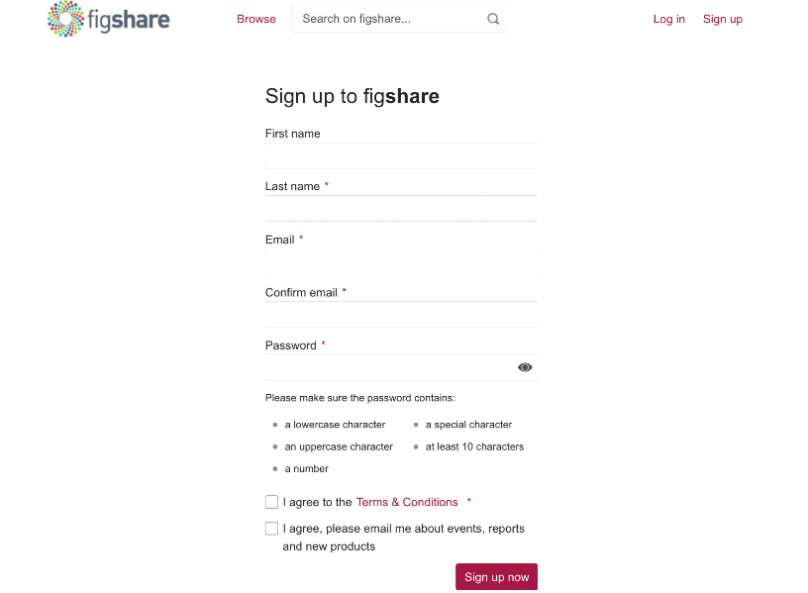

Login to Figshare https://figshare.com/account/login

Uploading your Supplemental material to Figshare

When you access your account page there are four tabs along the header. Through My data you can drag and drop files and create associated metadata.

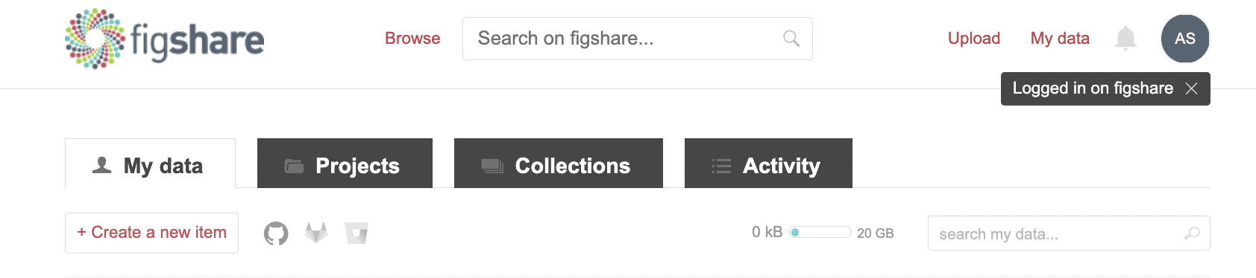

1. Select the +Create a new item button from the top left (or just drag and drop your file into the browser).

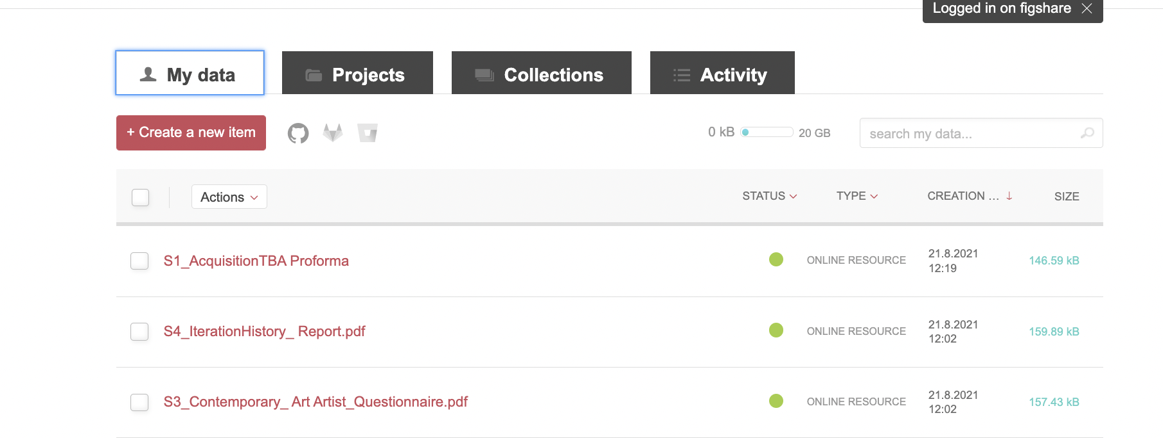

NOTE DATASIZE: All figshare.com accounts are provided with 20GB of storage and are able to upload individual files up to 20GB. For institutional users, your private space limit is dependent on your institution, please contact your institutional admins if you require more space.

2. To Upload browse or drag Supplemental material into the provided box in screen tab

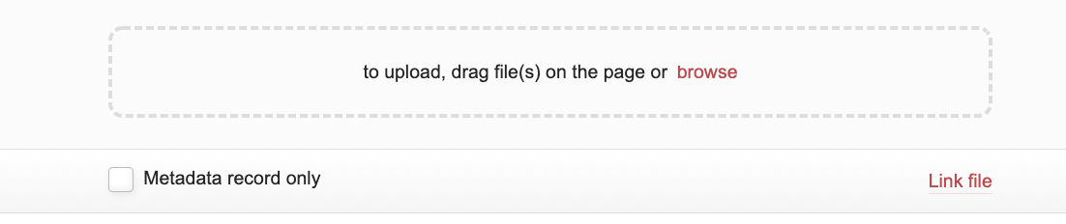

Once uploaded your Supplemental material will appear in the tab

Add associated metadata using the input fields:

- Insert a Title (Be descriptive for maximum exposure)

- Add Authors. You can rearrange the order in which the authors appear and remove yourself as an author if you are uploading on behalf of someone. You can search by entering the email address or ORCID of the author you want to add. To add an author who doesn’t have a Figshare account, select Add author details and enter their name, email address (optional), and ORCID (optional).

- Select a Category. These are taken from the Australian Fields of Research classification system. You can choose more than one and either select from the drop-down menu or search for your subject area.

- Select the Item type from the drop-down menu

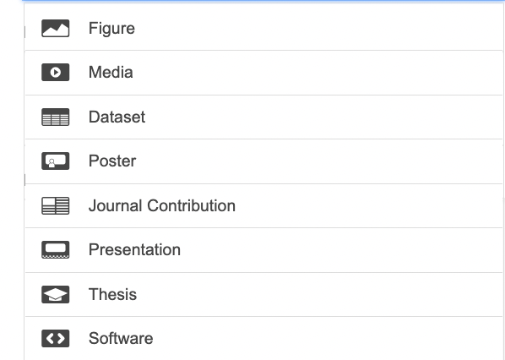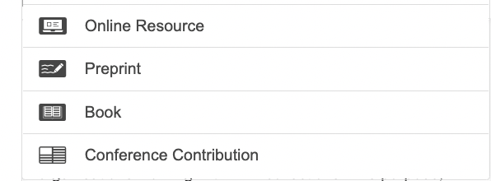

- Add Keyword(s). These should be more specific than the category and help others find your research. Add as many keywords as you want - just hit enter after each keyword. Figshare remembers ones you’ve entered previously and will suggest keywords based on keywords that have been added to the database previously.

- Write a Description. This should include any relevant information that pertains to your research - this might include information about the methodology, approval for data collection, or legal or ethical requirements. You can also paste HTML into this field or use journal article abstract.

- Funding information related to your Supplemental material and references to other materials related to your research outputs.

- Select a License.

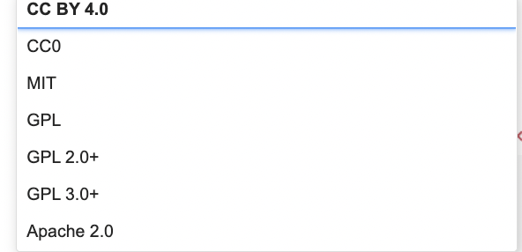

- Tick Publish. When doing so, you’ll be prompted to check the license you’ve assigned and the terms of use.

Once your Supplemental material is published the DOI can be shared for publication. This is a unique DOI for the Figshare Supplemental material – it is not the same DOI for the journal article.

Note: Only a Figshare for Institutions user, can see fields called Resource Title and Resource DOI. This is a set of fields that allow you to create a link between a peer-reviewed publication and your Supplemental material. This does not appear possible for single users.

- If you are not ready to publish, you can save the changes which will save the Supplemental material to your account but not publish the material.

You can create a private sharing links (that expire in 2037) to share your material in advance of publishing. Note: This is not a DOI and therefore this link is not suitable to embed within your journal paper.

See Metadata screen:
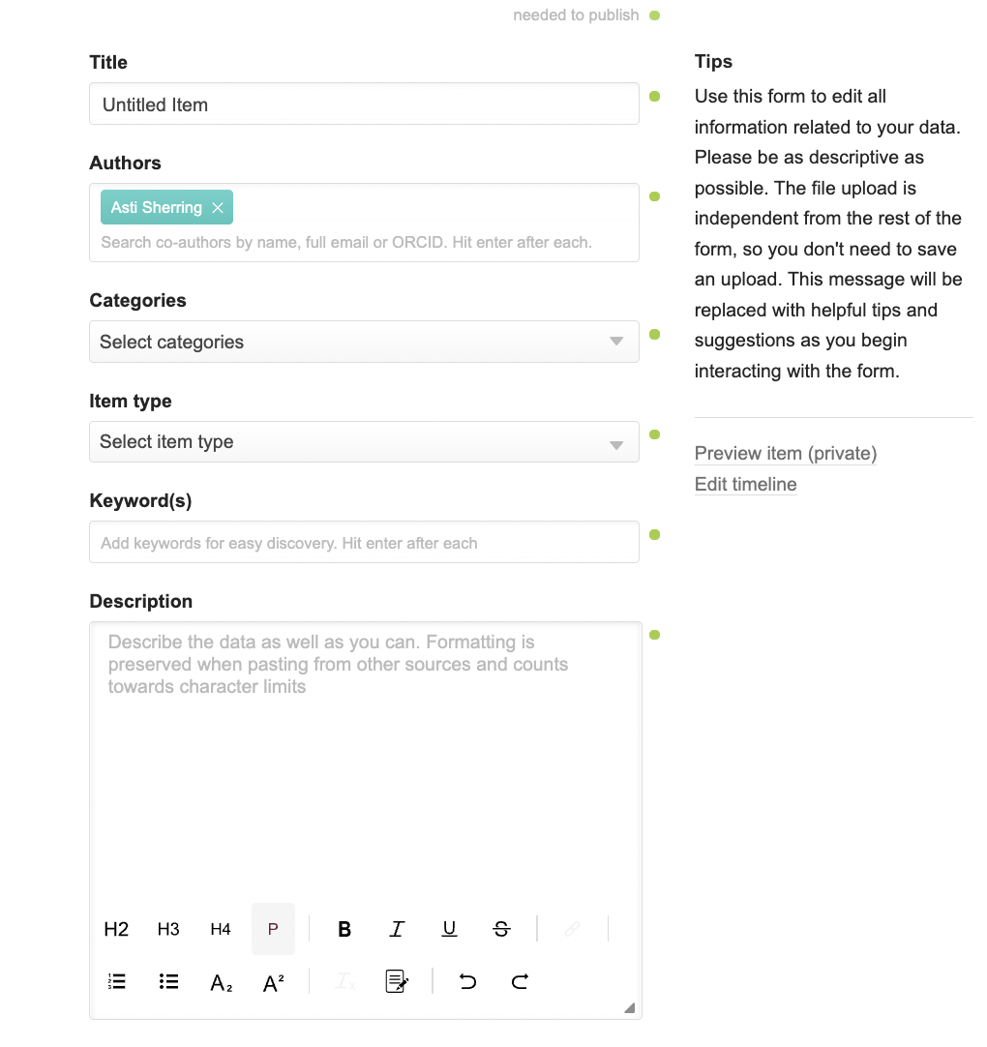

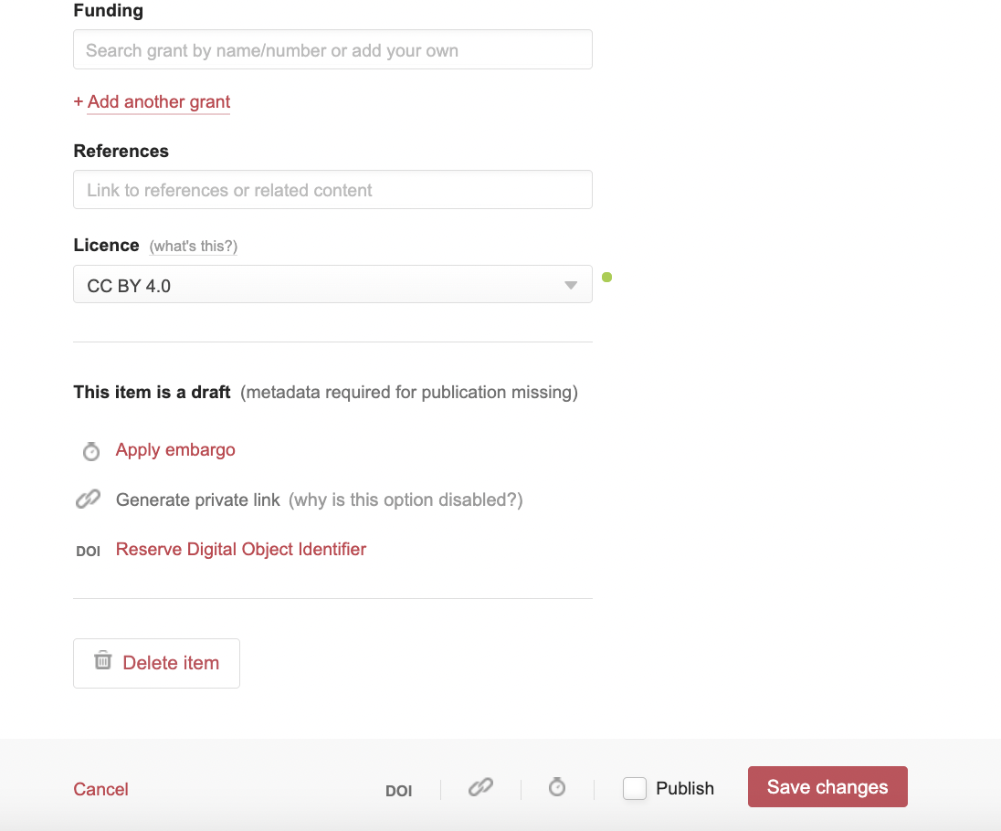

Linking Figshare data to AICCM Journal Article via Taylor and Francis (T&F)

- All supplemental material submitted as a part of your publication must be available to view as a part of the peer review process at the earliest possible stage. It is your decision whether you want to add the supplemental material to T&F portal as well as Figshare.

- You will need to clearly communicate during the publication process that you either:
- Do not want this material managed by T&F And only want access to supplemental material provided via Figshare
- Are happy to link to the material through T&F and Figshare

Note: if there are copyright implications related to your supplemental material or if you want to exercise creative commons (T&F licence agreement will assume copyright over this material) go with Figshare only option.

- If uploading to T&F as well as Figshare, the online portal upload options are limited the terms “figure” or “Appendix” are the most suitable.

- Clearly indicate in your paper where you want to link to Figshare supplemental material located. This will vary depending on the material and there may be format limitations when working with T&F publication staff.

- Use private links during the early paper review process to provide reviewers with secure access to supplemental material.

- Publish your Figshare supplemental material and UPDATE the link/s in your paper PRIOR to final editor approval to ensure that a unique DOI is created and that this DOI will be published. (If you are still using private links during the T&F publication stage, it will be difficult to change).

Considerations when working with T&F

At this time, it is not standard practice by T&F to include Figshare links in the paper and during the publication review process these links may be removed and/or changed. You will need to communicate with T&F publication team to rectify.

If you have uploaded the supplemental material through T&F portal it will be published and linked to your paper DOI as a part of the production process. Experience to date has shown that email requests not to publish supplemental material through T&F were unsuccessful. If you have copyright concerns do not upload the material to T&F portal.

Example
This data appeared at the end of the article after ‘Disclosure statement’

First link is to T&F portal (full paper)

Second link is DOI to Figshare dataset

