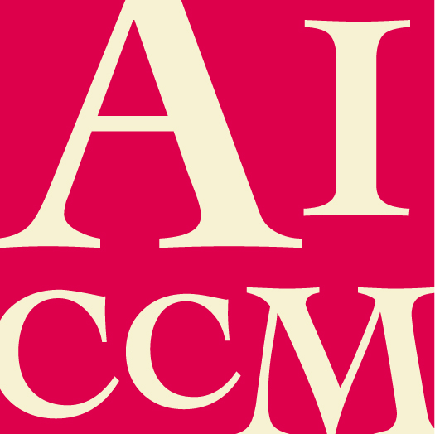
THE AICCM BULLETIN REFERENCING MANUAL
HARVARD (AUTHOR DATE) – EXAMPLES

Print
Includes any materials created for publication in paper form
Book
Basic format:
Author’s family name, Initial(s) OR Authoring body year, Title of book, Publisher, Place of publication.
Type of reference | In-text reference examples | Reference list examples | Further information
Book with 1 author  (this can include a person or an authoring body, e.g. a sponsoring  organisation) | Munoz Vinas (2005, p. 30) refers to…  ...was discussed (Munoz Vinas 2005, p. 43). | Munoz Vinas, S 2005, Contemporary theory of conservation, Routledge, New York.
Book with 2 or 3 authors | Odegaard, Carroll and Zimmt (2000, pp.128-29) state…  Positive test results in… (Odegaard, Carroll & Zimmt, 2000, pp. 128-29). | Odegaard, N, Carroll, S & Zimmt, W 2000, Material characterisation tests for objects of art and archaeology, Archetype Publications, London. | When multiple authors’ names are included within your sentence  (not in brackets) use the full spelling of ‘and’.  When the authors’ names are in brackets or in the reference list,  use ‘&’.
Book with 4 or more authors | As suggested by Ormsby et al. (2007a, p. 187)…  ...has been suggested (Ormsby et al. 2007a, p. 187). | Ormsby, B, Learner, T, Foster, G, Druzik, J & Schilling, M 2007a, ‘Wet-cleaning acrylic emulsion paint films: an evaluation of physical, chemical and optical changes’, in T Learner, P Smithen, J Krueger & M Schilling (eds), Modern Paints Uncovered, Getty Conservation Institute, Los Angeles, pp. 187–98. | When there are 4 or more authors, only use the first author’s name in-text followed by the abbreviation et al. But include all names in the reference list.
Book with no date or an approximate date | This is emphasized by Jones (n.d.) when...  This is emphasised by Jones (c. 2005) when... | Jones, B n.d., Conservation applications, Preservation Press, Melbourne.  Jones, B c. 2005, Conservation applications, Preservation Press, Melbourne. | If there is no date use n.d.  If there is an approximate date use c. (this means ‘circa’ –  Latin for ‘around/about’).
Book with no author | This was not the case before 1995 (The entrepreneur’s guide to the law 1999) | The entrepreneur’s guide to the law, 1999, Getty Conservation Institute, Los Angeles.
2nd or later edition of a book | Gascoigne (2004, p. 33) explains...  ...identification of prints  (Gascoigne 2004, p. 33). | Gascoigne, B 2004, How to identify prints: a complete guide to manual and mechanical processes from woodcut to inkjet, 2nd edn, Thames and Hudson, London. | The edition number comes directly after the title in the reference list.  Edition is not mentioned in-text.
Citation of another author | (Maurois, in Proust 1970) | Proust, M 1970, Jean Santeuil, trans. G Hopkins, Simon & Schuster, New York. Preface by Andre Maurois. | When citing an author other than the author of the source, provide both names.
Translated book | Waentig (trans. 2008) discusses plastics...  …approach to plastics in conservation (Waentig trans. 2008). | Waentig, F 2008, Plastics in art: a study from the conservation point of view, trans. M Scuffil, Michael Imhof, Petersberg. | The translator’s name is not referenced in-text – it only appears after the title in the reference list.

Edited book
Type of reference | In-text reference examples | Reference list examples | Further information
Edited (ed.), revised (rev.) or compiled (comp.) book | Villers (ed. 2000) questions  whether…  It is not clear whether this point  supports his previous assertions  (ed. Villers 2000). | Villers, C (ed.) 2000, The fabric of images: European paintings on textile supports in the fourteenth and fifteenth centuries, Archetype Publications, London. | When the editor’s name is included within your sentence  (not in brackets) place ed. in the  brackets following their name.  When the editor’s name is in brackets, put ed. before their name.
Edited (ed.), revised (rev.), translated (trans.) or compiled (comp.) book with 2 or 3 editors | Stoner and Rushfield  (2012) discuss easel paintings…  …is included in the conservation of easel paintings  (eds Stoner & Rushfield 2012). | Stoner, J & Rushfield, R (eds) 2012, The conservation of easel paintings, Routledge, Abingdon. | When editors’ names are included within your sentence (not in brackets) use the full  spelling of ‘and’.  When their names are in brackets or in the reference list, use ‘&’.  Note the use of ‘eds’ (no full stop) for multiple editors.
Edited book with 4 or more editors | In their collection of essays,  Cancino et al. (2014) explore...  …is explored throughout (eds  Cancino et al. 2014). | Cancino, C, Lardinois, S, Michiels, T & Balakrishnan, P (eds) 2014, Earthen architecture initiative seismic retrofitting project: a bibliography, Getty Conservation Institute, Los Angeles. | When there are 4 or more editors, only use the first editor’s  name in-text followed by the  abbreviation et al.  But include all names in the reference list.

Chapter in an edited book
Basic format:
Author’s family name, Initial(s) OR Authoring body year, ‘Title of chapter’, in Editor’s Initial(s) plus family name (ed.), Title of book, Publisher, Place of
publication, pp. x–xx.
Type of reference | In-text reference examples | Reference list examples | Further information
Chapter in an edited book | Smith and Scott (2009) argue that the conservation of...  It has been argued that… (Smith & Scott 2009, p. 31). | Smith, C & Scott, M 2009, ‘Ethics and practice: Australian and New Zealand conservation contexts’ in R Richmond & R Bracker (ed.), Conservation: Principles, dilemmas, and uncomfortable truths, Butterworth-Heinemann, Oxford, pp. 30-45. | Use the chapter author in your in-text reference. In the reference list the editor comes after the chapter title and is preceded by ‘in’.  Note the exception to the order of initials for editors– for chapters put the editor’s initial(s) before family name.

Journal article
Basic format:
Author’s family name, Initial(s) OR Authoring body year, ‘Title of article’, Title of Journal, vol. x, no. x, pp. x–xx.
Type of reference | In-text reference examples | Reference list examples | Further information
Journal article | Dredge (2012, p. 53) supports the view...  The view that… (Dredge 2012, p. 53). | Dredge, P 2012, ‘A history of Australian housepaint technology from the 1920s to the 1950s, with reference to its use by Australian artists, particularly Sidney Nolan’, AICCM Bulletin, vol. 33, pp. 53-61. | Follow the examples provided in the Books section re: varying number of authors.

Magazine
Type of reference | In-text reference examples | Reference list examples | Further information
Magazine article | Simpson (2014, p. 20) discusses changes in higher education…  …curriculum for museum professionals (Simpson 2014, p. 20). | Simpson, A 2014, ‘Rethinking university museums: material collections and the changing world of higher education’, Museums Australia Magazine, vol. 22, no. 3, pp. 18-22. | Publication information will vary between magazines: some have volume and/or issue numbers, while others show the month or date of publication. See examples provided.
Magazine article with no author | Museums Australia Magazine (2014, p. 8) highlights...  ...community service (Museums Australia Magazine 2014, p. 9). | Museums Australia Magazine 2014, ‘Spotlight on two colleagues honoured by the Order of Australia’, vol. 22, no. 3, pp. 8-9. | If a magazine article has no author, cite the magazine title as author.

Newspaper article
Type of reference | In-text reference examples | Reference list examples | Further information
Newspaper article | Tomazin (2002) states...  ...historical implications  (Tomazin 2002). | Tomazin, F 2002, ‘The treasures of Little Lonsdale’, Age, 19 July 2002. | Omit initial The in English language newspaper titles, e.g. The Australian, The Age.
Newspaper article with no author | The Conservation Times (25 June 2014, p. 29) examines...  ...big change (The Conservation Times 25 June 2014, p. 29). | The Conservation Times 2014, ‘New analytical method discovered’, 25 June, p. 29. | If a newspaper article has no author, cite the newspaper title as author and include the specific date of publication in brackets in‐text.

Government publication
Type of reference | In-text reference examples | Reference list examples | Further information
Australian Bureau of Statistics (ABS) publication | According to the Victorian Government Department of Planning and Community Development (DPCD) (2008), the guidelines...  ...historical archaeological surveys (DPCD 2008). | Victorian Government Department of Planning and Community Development (DPCD) 2008, Guidelines for conducting historical archaeological surveys, DPCD, Victoria. | If you cite the authoring body frequently in‐text, introduce the organisation name in abbreviated form in brackets after the first citation. Use this abbreviation for subsequent citations, e.g. (DPCD 2008).
Government report | …private conservation activities (PC 2006, p. 114). | Productivity Commission (PC), 2006, Conservation of Australia’s historic heritage places, Report no. 37, Australian Government, Canberra.

Legal publication
Type of reference | In-text reference examples | Reference list examples | Further information
Legislation: Acts, Ordinances, Regulations | As stated in the Victorian Heritage Act 1995, the legislation…  …as stated in the legislation  (Victorian Heritage Act 1995). | Victorian Heritage Act 1995 (VIC). | Cite in this format no matter where you found it. Do not include URLs for legislation found online.
Legal case | In the case of Fabcot Pty Ltd v Heritage Victoria (1997/68606) (1997) VICCAT 1039, it was… | Fabcot Pty Ltd v Heritage Victoria (1997/68606) (1997) VICCAT 1039. | Cite in this format no matter where you found it. Do not include URLs for legislation found online.

Patent or standard
Type of reference | In-text reference examples | Reference list examples | Further information
Standard | Standards Association of Australia  (1996) provides...  ...covering colours (Standards  Association of Australia 1996). | Standards Association of Australia 1996, Colour standards for general purposes: chocolate, AS 2700S‐1996 (X64), Standards Australia, North Sydney.

Dictionary, encyclopaedia or handbook (reference works)
Type of reference | In-text reference examples | Reference list examples | Further information
Dictionary or encyclopedia without author(s) or editor(s) | According to the Macquarie Dictionary (2013, p. 147) … | N/A | For a standard dictionary with no core author(s) or editor(s), only cite in‐ text.
Handbook | Kobilinsky (2012) advises…  …is advised (Kobilinsky 2012). | Kobilinsky, L (ed.) 2012, Forensic chemistry handbook, John Wiley & Sons, Hoboken, New Jersey.

Conference paper or thesis
Type of reference | In-text reference examples | Reference list examples | Further information
Conference paper  (in published proceedings) | Scott (2008, p. 121) offers...  Implications have been demonstrated… (Scott 2008, p. 121). | Scott, M 2008, ‘Conservation interdisciplinarity and pedagogical implications’, in J Bridgeland (ed.), ICOM Committee for Conservation, 15th Triennial Conference, 22-26 September, New Delhi, Allied Publishers Pvt. Ltd., New Delhi, vol. 2, pp. 121-127. | To cite a whole book of conference proceedings, follow the format for citing an edited book.
Thesis | Rajkowski (2013, p. 8) offers...  It was demonstrated… (Rajkowski 2013, p. 8). | Rajkowski, R 2013, ‘Liquitex acrylic emulsion paint: developing baseline data for material investigation of works of art by contemporary artists’, CCMC minor thesis, The University of Melbourne, Melbourne. | Do not italicize thesis titles like standard books; instead, place them inside inverted commas.

Miscellaneous
Type of reference | In-text reference examples | Reference list examples | Further information
Unpublished report (e.g. a condition report, interview transcript, letters) | Hook and Osmond (1994) refer to…  It has been found… (Hook & Osmond 1994).  It has been found that Dulux paints… (Leary, Bray & Brice 2013)  When interviewed on 15 June 1994, Dr Betty Daly explained that … or this was verbally confirmed (B Daly 1994, pers. comm., 15 June). | Hook, J & Osmond, G 1994, ‘Conservation and analytical reports of kite flying and epiphany’, condition report, QAGOMA Conservation Department, QAGOMA, Brisbane.  Leary, B, Bray, C & Brice, J 2013, ‘Summary of BALM Paints sourced from Dulux Group Australia Pty Ltd Archives and oral history sources,’ unpublished notes, QAGOMA Conservation Department, QAGOMA, Brisbane, 7 October.  Daly, B 1994, Interview transcript on the Materials and Techniques of Paint Production in Melbourne, Melbourne, 22 October. | You can use this format for interview transcripts too.
Duplicated material (microfiche, photocopy) | (Tse 2014) | Tse, N 2014, Conservation in the field course notes, photocopy, Centre for Cultural Materials Conservation, University of Melbourne, Melbourne.
Pamphlet or brochure (ephemera) | Jones and Holden (2008) suggest...  ...has been suggested (Jones & Holden 2008). | Jones, S & Holden, J 2008, It's a material world: caring for the public realm, DEMOS, viewed 26 June 2014, <www.demos.co.uk/publications/materialworld>. | As details will vary when it comes to  Brochures and pamphlets, try and extract as much information as you can re: authorship, publication details etc.
Conference paper (unpublished) | (Kowalski 2012) | Kowalski, V 2012, ‘Artist materials during the 1940s, with a focus on Arthur Boyd’s paintings in the Heide Museum of Modern Art Collection’, paper presented to the 2012 AICCM Paintings Group + 20th Century in Paint Symposium, The Meaning of Materials in Modern and Contemporary Art, Brisbane 10 – 11 December 2012.
Workshop lecture notes or slides | ...valuable information (Brown 2014). | Brown, A 2014, ‘Experimental findings’, Chemistry Workshop, Centre for Cultural Material Conservation, Melbourne, 26 June. | Verify with your tutor or course Coordinator whether it is appropriate to cite lecture notes in your writing.

Online (electronic)
Includes any materials created for publication online or electronically

Webpage or website
Basic format:
Author’s family name, Initial(s) OR Authoring body year, Title of webpage or website, Website (if citing webpage) AND/OR Publisher if known, date viewed, <URL>.
Type of reference | In-text reference examples | Reference list examples | Further information
Whole website | The Department of Transport, Planning and Local Infrastructure (2014) takes… | Department of Transport, Planning and Local Infrastructure 2014, Department of Transport, Planning and Local Infrastructure, State Government of Victoria, viewed 20 June 2014, <http://www.dpcd.vic.gov.au/>. | Italicise the focal point of the reference: if citing a whole website, italicise the website title; if citing a specific webpage on a website, italicise the webpage and present the website name in plain font.
Single page on a website | …heritage is explored (Department of Transport, Planning and Local Infrastructure 2014). | Department of Transport, Planning and Local Infrastructure 2014, Heritage, State Government of Victoria, viewed 20 June 2014, <http://www.dpcd.vic.gov.au/heritage>.

Online journal article
Type of reference | In-text reference examples | Reference list examples | Further information
Journal article accessed via a library database | Ormond-Parker and Sloggett (2012) suggest…  …effects may be minimised (Ormond-Parker & Sloggett 2012). | Ormond-Parker, L & Sloggett, R 2012, 'Local archives and community collecting in the digital age', Archival Science, vol. 12, no. 2, pp. 191–212. | When an article is accessed using an electronic database, reference it as a standard journal article (see Print section); do not include date viewed, URL or refer to the database.
PDF version of a print journal article accessed via the internet (e.g. Google, Google Scholar, Muse, JSTOR) | Scott’s (2008, p.38) research showed…  …are realised (Scott 2008, p. 38). | Scott, C 2008, 'Using “values” to position and promote museums', International Journal of Arts Management, vol. 11, no. 1, pp. 28–41. | When the article is a scanned PDF version of a print journal article that you found online, reference it as a standard journal article (see Print section). If unsure about its print or online origin, include date viewed and URL.

Online news item
Type of reference | In-text reference examples | Reference list examples | Further information
Article on a news website | McColl (2013) investigates…  …serious consequence (McColl 2013). | McColl, G 2013, ‘Have huge touring shows turned our public galleries and museums into mere venues for hire?’, Sydney Morning Herald, 12 May, viewed 20 June 2014, <http://www.smh.com.au/entertainment/art-and-design/blockbusted-20130511-2jf6r.html>. | Reference like a print newspaper article with date of publication, and also include date viewed and URL.
Article on a magazine-style website | Irwin (2013) explains…  …found it presents difficulties (Irwin 2013). | Irwin, S 2013, ‘Paper conservation in the far north: a project summary from Alaska’, e-conservation magazine, Spring, viewed 20 June 2014, <http://www.e-conservationline.com/content/view/1098>. | Reference like a print magazine article, and also include date viewed and URL.

E-book or online document
Type of reference | In-text reference examples | Reference list examples | Further information
E-book accessed via the internet | Feller (1994) focuses on… | Feller, R 1994, Accelerated aging: photochemical and thermal aspects, Research in Conservation 4, Getty Conservation Institute, Marina del Rey, viewed 20 June 2014, <http://www.getty.edu.au/conservation/publications_resources/pdf_publications/accelerted_aging.html>. | Include viewing date and URL after standard publication information.
E-book accessed via a database | Stuart (2007, p. 14) states… | Stuart, B 2007, Analytical techniques in materials conservation, John Wiley & Sons, London, viewed 20 June 2014, E-book Library. | Include the viewing date and database name/provider after standard publication information.
E-book accessed via an e-reader (e.g. Kindle) | Davison & Newton (2008, ch.2) note the importance of… | Davison, S & Newton, R 2008, Conservation and restoration of glass, Kindle, 2nd edn, Butterworth-Heinemann, Oxford. | Include device type before publication information. When normal pagination is not present, cite chapter numbers (ch.) or similar.
Online documents in PDF, Word or Excel form | Somers Cocks & Jones (2010) consider… | Somers Cocks, A & Jones, S 2010, 'Conservation in crisis: communicating the value of what we do', Dialogues for the New Century, IIC Transcript, 28 January, Hochhauser Auditorium in the Sackler Centre of the Victoria and Albert Museum, London, viewed 20 June 2014, <https://www.iiconservation.org/sites/default/files/dialogues/conservation_in_crisis_en.pdf>. | If you cite the authoring body frequently in-text, introduce and then use an abbreviation for subsequent citations.

Miscellaneous
Type of reference | In-text reference examples | Reference list examples | Further information
Systematic review | Millward et al. (2009) review…  …was found in the review (Millward et al. 2009). | Millward, C, Ferriter, M, Calver, S & Connell-Jones G 2009, Gluten-and casein-free diets for autistic spectrum disorder, Cochrane Database of Systematic Reviews, art. No. CD003498, DOI: 10.1002/14651858.CD003498.pub3. | Include the article number and the DOI. The URL is not needed in the reference list.
Electronic thesis | Douglas (2005) argues…  …viable cultural institution (Douglas 2005, p. 2). | Douglas, C 2005, ‘Cultivating the [new] country: disclosing through curatorship the cultural and economic development potential of the Australian Regional Art Museum’, PhD thesis, Queensland College of Art, Griffith University, Nathan, viewed 20 June 2014, <http://www4.gu.edu.au:8080/adt-root/public/adt-QGU20060901.111309>. | Theses formerly housed in the Australian Digital Theses Collection are now accessible through the National Library of Australia’s Trove Service.
Conference paper (in online proceedings) | …important claim (Kondo et al. 2009). | Kondo, Y, Kaneda, A, Fujimoto, Y, Seino, Y & Uozu, T 2012, ‘The CEDACH DMT: a volunteer-based data management team for the documentation of the earthquake-damaged cultural heritage in Japan’, Revive the past: proceedings of the 39th conference in computer applications and quantitative methods in archaeology, Beijing, China, 12-16 April 2011, pp. 326-33, viewed 20 June 2014, <http://proceedings.caaconference.org/files/2011/36_Kondo_et_al_CAA2011.pdf>.
Email correspondence | Scott confirmed this by email on 25 June 2014. | M Scott, email, 25 June 2014. | According to Harvard (author date) a reference is not required for email communication, however for AICCM Bulletin purposes it is preferable to include. Also get approval from the email’s author.
Social networking update (e.g. Twitter, Facebook) | The National Gallery of Victoria (2014) is currently running a series of events on Fridays… | National Gallery of Victoria (NGV) 2014, ‘Friday nights: Italian masterpieces,’ Facebook, 30 June, National Gallery of Victoria, viewed 26 July 2014, <https://www.facebook.com/NGVMelbourne>. | If you cite the authoring body frequently in‐text, introduce the organisation name in abbreviated form in brackets after the first citation. Use this abbreviation for subsequent citations, e.g. (NGV 2014).
Messages posted to discussion boards, lists, newsgroups | Ellis (2014) states… | Ellis, M 2014, ‘On William Blake, access and quiet(er) conservation’, Student Conservators @ Melbourne, 27 April, viewed 27 June 2014, <http://studentconservators.com/post/83977864736/on-william-blake-access-and-quiet-er-conservation>. | Identify the type of post (e.g. list server, blog post) after the title of post. Put the title of post in single quotation marks and the name of the whole blog in italics.
Blog post | Anderson (2014) describes… | Anderson, N 2014, ‘Re-binding stories of voyages bound to Australia’, blog post, 3 June, National Library of Australia, viewed 20 June 2014, <http://www.nla.gov.au/blogs/preservation/2014/06/03/conservation-after-digitisation-the-shippboard-journal-project>.
Sound and Visual
Includes any materials created for film, television or audio. Please note in most cases you need to include the format of your source in your
reference list entry.

Film or television
Type of reference | In-text reference examples | Reference list examples | Further information
Film (cinema release) | The Monuments Men (Clooney 2014) depicts… | Clooney, G (dir.) 2014, The Monuments Men, motion picture, Columbia Pictures. | Cite a film’s director (dir.) as main author. Where directors are not identified, cite the producer (prod.) or authoring company.
Film on DVD, Blu-Ray, videotape, iTunes etc. | The Thomas Crown Affair (McTiernan 1999) presents… | McTiernan, J (dir.) 1999, The Thomas Crown Affair, DVD, Metro-Goldwyn-Mayer.
Television program | An episode of How It’s Made (Science Channel 2013) examines… | Science Channel 2013, How It’s Made, television program, Science Channel, 1 August. | Cite a program’s director (dir.) as main author. Where directors are not identified, cite the producer (prod.) or authoring company instead.  For TV transmissions, include channel and screening date in your reference list entry. If year of screening differs from year of production, include year of screening in the screening date.
Episode of a television program/series | Colour In Your Life (2012) chronicles… | Stevenson, G (dir.) 2012, ‘Dave Behrens’, Colour In Your Life, TV 4Me, 24 June 2012.
Episode of a television program/series on DVD, Blu-Ray, videotape, iTunes etc. | In the first episode of The Art of Australia (Turley & Lambert 2013) series, the… | Turley, L & Lambert, T (dirs.) 2013, The Art of Australia, ep. 1, DVD, ABC and BBC.

Miscellaneous
Type of reference | In-text reference examples | Reference list examples | Further information
YouTube clip or program | A short video by Multicultural Arts Victoria (2013) provides… | Multicultural Arts Victoria 2013, Destination: Shepparton, video, Vimeo, 4 September, viewed 20 June 2014, <http://vimeo.com/60370033>. | Use this format for other online clips or programs from sites like Vimeo, YouTube, Dailymotion.
Music recording on CD, iTunes etc. | Petran (2009) brings together… | Petran, P 2009, Music Deli presents Archie Roach - 1988, CD, ABC.
Podcast | …were identified (Tyreman, Cherry & Salter 2014). | Tyreman, K, Cherry, D & Salter, R 2014, V&A podcast - Women artists, podcast, Victoria and Albert Museum, viewed 27 June 2014, <http://www.vam.ac.uk/content/articles/v/v-and-a-podcast-women-artists/>. | When podcasts are downloaded or streamed from iTunes, write iTunes instead of URL.
Radio program | …inspired by their cultural heritage (Petran 2011). | Petran, P 2011, ‘Music Deli from the archives’, Music Deli, radio program, ABC Radio National, 20 May.
Interview transcript | Fairweather (1965) stated that…  The artist states that he painted without turpentine… (Fairweather 1965). | Fairweather, I 1965, Ian Fairweather interviewed by Hazel de Berg in the Hazel de Berg Collection, sound recording, Hazel de Berg Collection, National Library of Australia, Canberra; DeB 153, 26 Nov 1965.
Lecture recording | …essential step (Nel 2014). | Nel, P 2014, ‘Condition report intensive’, CUMC40007, University of Melbourne, Parkville, 5 May 2014. | Verify with your tutor or course coordinator whether it is appropriate to cite a lecture recording in your academic writing.
CD-ROM | …valuable tool (The West End conservation manual 2004). | The West End conservation manual 2004, CD-ROM, Glasgow Conservation Trust, Glasgow.
Video game | Halo: reach (Bungie 2010), a prequel to… | Bungie 2010, Halo: reach, video game, Xbox 360, Microsoft Game Studios. | For most games, cite the developing company as author.
Computer program | …software was launched (Ara Irititja 2010). | Ara Irititja 2010, Ara Irititja KMS, computer software, Pitjantjatjara Council Inc., Central Australia.

Other
Includes miscellaneous materials

Miscellaneous
Type of reference | In-text reference examples | Reference list examples | Further information
Artwork (e.g. painting, sculpture) | McCubbin’s 1891 work The North Wind, housed in the National Gallery of Victoria, depicts… | N/A | Works of art and live performances cannot easily be recovered by readers, so describe them in detail in-text instead of referencing.
Live performance (e.g. theatre, speech) | The Melbourne Theatre Company’s 2013 production of The Mountaintop, drew… | N/A
Personal communication (e.g. letters, conversation) | Scott (2014, pers. comm., 1 May) comments that interdisciplinarity is…  An expert in the field of cultural materials…. (Scott 2014, pers. comm., 1 May). | Scott, M 2014, ‘Teaching and learning in cultural materials conservation,’ interview transcript, Melbourne, 1 May. | According to Harvard (author date) a reference is not required for personal communication, however for AICCM Bulletin purposes it is preferable to include.  Include as an unpublished report. Also get approval.
Database | (CCMC FFS database) | CCMC FFS database, Centre for Cultural Materials Conservation, Filemaker Pro, annual updating. | Databases are identified by their title and producer.
Image/diagram/artwork from a print source | 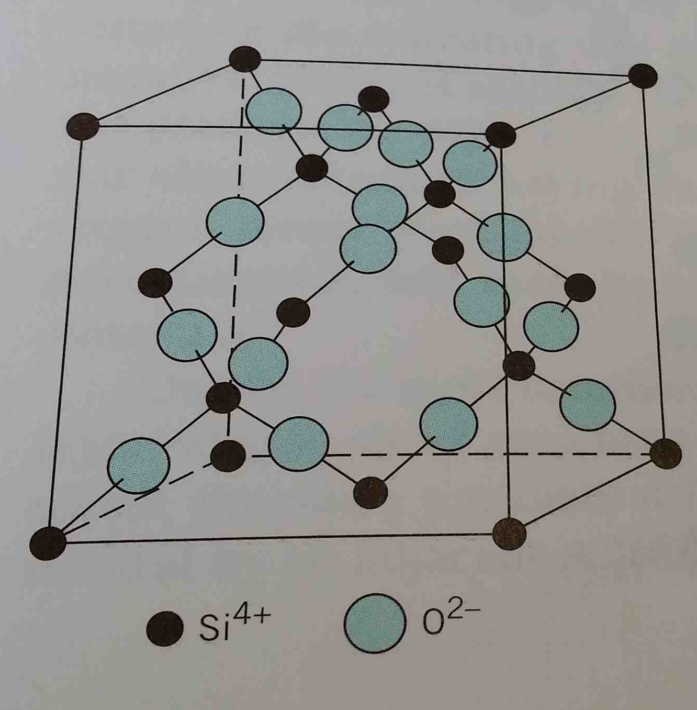  The arrangement of silicon and oxygen atoms in a unit cell of cristobalite, a polymorph of SiO2 (Callister 2003, p. 395). | Callister, WD 2003, Materials science and engineering: an introduction, 6th edn, John Wiley & Sons Inc, New York. | Cite the source where the image was located using the standard format for that source.
Image/diagram/artwork from an online source | 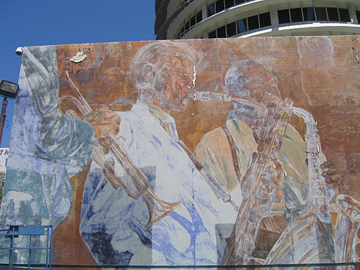  Hollywood Jazz: 1945-1972 (Learner 2007). | Learner, T 2007, Detail of Hollywood Jazz: 1945-1972 by Richard Wyatt, The J. Paul Getty Trust, viewed 26 June 2014, <http://www.getty.edu/conservation/our_projects/science/modcon/modcon6.html >.
Map | According to the map of the region, (Department of Premier and Cabinet 2014) the area highlighted… | Department of Premier and Cabinet 2014, Map of Victoria – areas of cultural heritage sensitivity, The State of Victoria, Department of Sustainability and Environment, Melbourne. | If the map is derived from an atlas, cite the atlas in standard book format.

