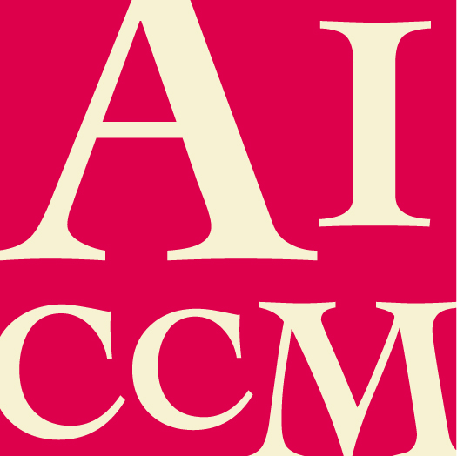 | Conservation Treatment of the Year  NOMINATION FORM

The nominee must be a current financial member of AICCM.
All sections of this form must be completed for this nomination to be valid.

Nominee details

- Name of nominee

- Name of employer / organisation

- Position / Title (if relevant)

- Contact phone number and email address

Response to Selection Criteria (attached at the end of this form)
- Provide a short description of the object and treatment undertaken. The award will be judged on results (before and after), treatment innovation, collaboration and public exposure.

Additional comments
- Please make any additional comments in support of this nomination. The nominator is encouraged to include any relevant support material eg media coverage, letters of support etc.

Nominator and Seconder details
Please supply your and the seconder’s details, in the event that the Selection Panel need to confirm nomination information.

 | Nominator | Seconder
Name
Organisation
Position/Title
Phone no.
Fax no.
Email
Signature
Date

Submission details

Please return this completed form and any support material to AICCM Secretariat
secretariat@aiccm.org.au

Selection Criteria
Suitable candidates exhibit the following criteria:

(a) The individual must be a member of AICCM
(b) The treatment must have taken place within the last 12 months

Evaluation Rubric

Category | Exceeds award requirements | Meets award requirements | Does not meet award requirements
Results (before and after) | - Excellent results with extensive visible improvement | - Good results with some visible improvements | - Unsatisfactory results  - No documentation
Treatment innovation | - Using materials and/ or techniques that have not been used before | - Using materials and/ or techniques that are rarely used or are not well known by other conservators  - Apply existing materials and/ or techniques in a new context | - Carried out a routine treatment
Collaboration | - Collaborated with conservators from other specialisations and workplaces, as well as specialists from outside conservation | - Collaborated with conservators from own specialisation and work-place. | - Carried out treatment in isolation
Public exposure | - Publicised in mainstream media / overseas/ outside of the conservation sector. | - Publicised within the conservation sector in Australia | - Known only by the person carrying out the treatment

