AUSTRALIAN INSTITUTE FOR THE CONSERVATION OF CULTURAL MATERIAL INC.
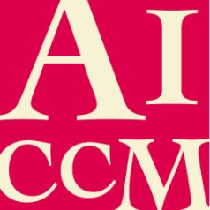

Proposal (Proforma)

[Title]

Name of Presenter:
E.g. Jo Smith

Name/s of all Co-presenters:
E.g. Jo Smith 1 and Jane Doe2

Affiliations:
Eg.
1 Australian Gallery of Art
2 Museum of Australia

Participation format:
(Please use checkbox or mark with ‘X’. Proposals in more than one category welcome)
☐ 20 minute Powerpoint presentation
☐ Open-format multimedia submission (2-20 minutes, or longer by agreement)
☐ Virtual poster (limit of 1000 words)

Technical support (optional): Please let us know what kind of technical information and support you would like us to provide

Proposal: [up to 200 words]
Write your proposal here. The emphasis is on communication so there are no strict formatting requirements

Brief Biography of the Author(s):
In 50 words or less, provide a biography of your key achievements and professional interests. This bio may be reproduced in the event program

