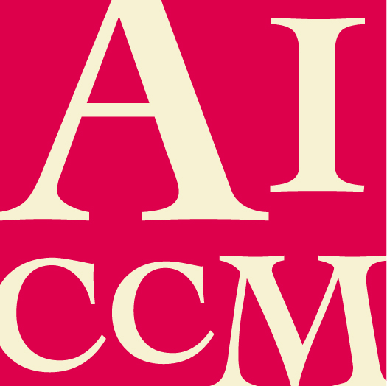 | Service to the Conservation Profession Award  NOMINATION FORM

The nominee must be a current financial member of AICCM.
All sections of this form must be completed for this nomination to be valid.
If information in this nomination is more relevant to a different AICCM Award category, this nomination can be considered in that category instead. Please state any category you DO NOT wish this application to be considered for.

This award recognises an AICCM member or institutional member who has contributed to the profession either over the long term or a single project through at least 2 of the following:
- active involvement in delivering conservation seminars, workshops and other educational/learning opportunities;
- mentoring of other conservators;
- promotion of conservators and/or conservation within and beyond the profession
- by working with allied professions and the public.

Nominee details

- Name of nominee
- Name of employer / organisation
- Position / Title
- Contact phone number and email address

Response to Selection Criteria (attached at the end of this form)

Please describe how the nominee has met the selection criteria.
Additional comments

Please make any additional comments in support of this nomination. The nominator is encouraged to include any relevant support material eg media coverage, letters of support etc

Nominator and Seconder details

Please supply your and the seconder’s details, in the event that the Selection Panel need to confirm nomination information.

 | Nominator | Seconder
Name
Organisation
Position/Title
Address
Phone no.
Fax no.
Email
Signature
Date

Submission details

Please return this completed form and any support material to AICCM Secretariat
secretariat@aiccm.org.au

Selection Criteria

- Current financial member of AICCM.
- Evidence of sustained contribution to and promotion of the profession.
- Demonstrable long term benefits of their endeavours on the profession.
- Demonstrated commitment to the profession and the wider community.
- Evidence of mentoring AICCM members.
- Details of the number and variety of projects working with allied professions and the public.

