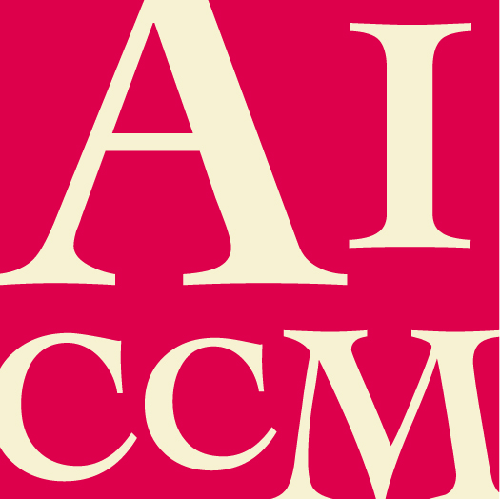 | AICCM Medal  NOMINATION FORM

The nominee must be a current financial member of AICCM.

All sections of this form must be completed for this nomination to be valid.

If information in this nomination is more relevant to a different AICCM Award category, this nomination can be considered in that category instead. Please state any category you DO NOT wish this application to be considered for.

This award recognises career long contributors to Conservation and acknowledges skills sharing across levels of seniority ensuring that skills are not lost from the profession.

Nominee details

- Name of nominee

- Name of employer / organisation

- Position / Title

- Contact phone number and email address

Response to Selection Criteria (attached at the end of this form)

- Please describe how the nominee has met the selection criteria.

Additional comments

- Please make any additional comments in support of this nomination. The nominator is encouraged to include any relevant support material eg media coverage, letters of support etc

Nominator and Seconder details

Please supply your and the seconder’s details, in the event that the Selection Panel need to confirm nomination information.

 | Nominator | Seconder
Name
Organisation
Position/Title
Address
Phone no.
Fax no.
Email
Signature
Date

Submission details

Please return this completed form and any support material to AICCM Secretariat
secretariat@aiccm.org.au

Selection Criteria

- The nominee must be a current member of AICCM.
- evidence of length and complexity of their contribution to and promotion of the profession.
- involvement, either past or present, in AICCM divisional or national activities. Details of this involvement may also include a list of published materials.
- Demonstrable long term benefits of their contribution to the profession nationally or internationally.
- Evidence of mentoring within the profession and participation in formal and informal networking activities to the benefit of conservation

- Evidence of contribution via working with allied professions and the public.
- Cannot have received the award before.

- The Selection Committee may choose to defer making an award if it considers that candidates have not met the criteria.

