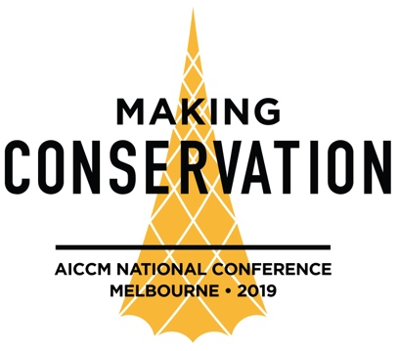

Abstract (Proforma)

[Title]

Name of Presenter:
E.g. Jo Smith

Name/s of All Co-authors:
E.g. Jo Smith1 and Jane Doe2

Affiliations:
Eg.
1 Australian Gallery of Art
2 Museum of Australia

Abstract: [250 words]
Write your abstract here. The emphasis is on communication so there are no strict formatting requirements although if you wish, you might refer to:
Background/ rationale/significance/theory;
Study methods, clear statement of arguments/evidence;
Conclusions.

Brief Biography of the Author(s):
In 50 words or less, provide a biography of your key achievements. This bio may be reproduced in the Conference Program.
Highlight Your Preferred Conference Category:
Making Conservation Connected
Making Conservation Sustainable
Making Conservation Innovative
Note that you can pick multiple categories. Your paper’s category will be ultimately decided on by the conference committee.

Highlight Your Format:
· Paper (20 minutes)
· Lightning talk (5 minutes)
· Poster
· Panel discussion (45 minutes – 1 hour)
· Short video presentation (Please indicate length)
· Other: ______________________

