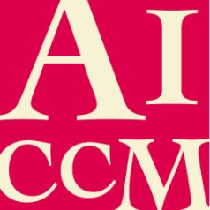
AUSTRALIAN INSTITUTE FOR THE CONSERVATION OF CULTURAL MATERIAL INC.

AICCM PSIG-SCC Conference: ‘Managing Risks to Collections’ Abstract submission

[Title]

Name of Presenter:
E.g. Jo Smith

Name/s of All Co-authors:
E.g. Jo Smith 1 and Jane Doe 2

Affiliations:
Eg.
1 Australian Gallery of Art
2 Museum of Australia

Preferred format (please number in order of preference if relevant):
___ Paper
___ Lightning talk
___ Poster

Abstract : [300 words]
Write your abstract here. The emphasis is on communication so there are no strict formatting requirements although if you wish, you might refer to:
Background/ rationale/significance/theory;
Study methods, clear statement of arguments/evidence;
Conclusions.

Brief Biography of the Author(s) :
In 50 words or less, provide a biography of your key achievements. This bio may be reproduced in the Conference Program.
For those wishing to present a paper, please complete the following:
I/We intend to submit this as an article for the AICCM Bulletin: ☐ yes ☐ no
We encourage you to submit your work to the AICCM Bulletin. By indicating here that you intend to submit to the Bulletin, it will assist forward planning for the Editorial Committee.
Please send this completed form to Amy Bartlett at amy.bartlett@launceston.tas.gov.au by Friday 2nd November, 2018.

